**EXPENSE TRACKER**

**Entity-Relationship Diagram :**

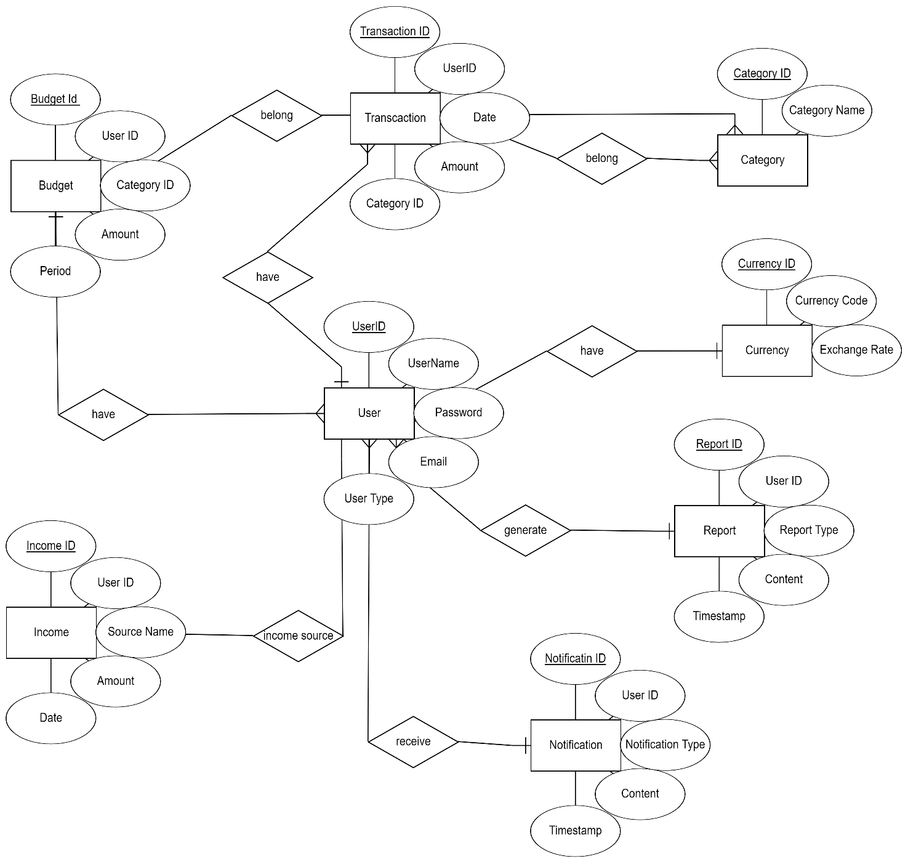

**Class Diagram :**

